CORPORATE ENLIGHTENMENT
What did you learn today?

How could Corporate Enlightenment change your world?

It could show you a whole New World™

- Have you ever felt like somebody is watching you?
- Have you ever felt that your work is underappreciated?
- Do you think that capitalism is wrong?
- If you could erase the world as we know it and built a fundamentally new state, where we all work together for one end goal. Would you?

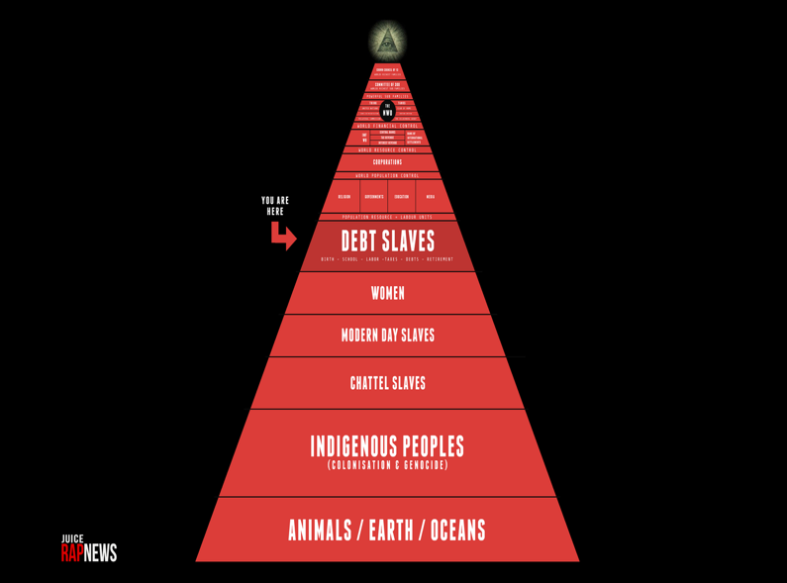
If you think your life isn’t going down the right angle, think triangle!

